JPMC Placement Experience
Batch(2019-2023)

Name : Hanish Valecha
Job Offered : Yes & Accepted
CGPI : 9.79
Criteria : 7CGPA+
Email : hanishvalecha36@gmail.com
Contact Number : 7249696720
Linkedin : https://www.linkedin.com/in/hanish-valecha-6a1a67212/

TimeLine:

JPMC RoadShow (Pre-placement Online event - Zoom) | 4, 7 and 8 March 2022
Approximately 4-5 day window was given for attempting Coding Round and Interviews since the emails were sent out in batches.
Coding Round (Hackerrank) | 18-20 March 2022
Interview Round (HireVue) | 26 March - 1 April 2022
Shortlist Result | 09 May 2022
CodeForGood Bootcamps (GitHub, Office Hours, Presentation Skills) - Zoom | 24-26 May 2022 (1 hr sessions every day)
Slack Invites | 25 May 2022
BeMyApp Registration Invites | 08 June 2022
JPMC CodeForGood Hackathon | 11 - 12 June 2022
Final Shortlist Result | 19 July 2022

About Rounds :

Round 1:

Round 1 was a coding test that took place in the 6th semester in the 3rd year. These were Questions related to Strings,array,linked list,stacks and queues.This company doesn't go deep into trees,graphs and dynamic programming questions.So practice as much questions as you can on hackerrank and leetcode before test and then you will good to go for coding test.
If any one wants guidance on how to stairt dsa and increase level gradually can contact me anywhere.Also start practicing DSA questions from the start of 2nd year.

Believe me if you have done practice of more than 200/300 questions and cleared with basic concepts of topics told above then you will easily crack this round.

It had 2 questions for which the choice of language was given to the candidate. I had practiced in Java , so I went ahead with that. It comprised of 2 questions:

Q1: Reverse Complementing a DNA Strand,in this question we had to reverse the string and replace the letters in it with its complements which was given in question.(Easy Question)
For more you can watch this video: https://www.youtube.com/watch?v=1J_u6fS8xz4

Q2: Growth in 2D Dimensions in infinite matrix (Medium to Hard level question).

Question link: https://www.chegg.com/homework-help/questions-and-answers/1-growth-2-dimensions-start-infinite-two-dim0ensional-grid-filled-zeros-indexed-1-1-bottom--q92501293

Solution link:
See second solution on this link.
https://stackoverflow.com/questions/62253968/how-to-solve-two-dimensional-growth-grid-problem

Important Guidelines:

- Your camera has to be switched on at all times during the test.

- Hackerrank has strict plagiarism detection software that makes use of M.O.S.S which
can easily identify whether your code is original or not.

Round 2:

Link for attempting round 2 was soon mailed to us with instructions to attempt
Platform of interview was Hirevue. If you do some background research about the platform it uses AI so things like your confidence, expressions, voice, lightings play a very major part.

Questions : Questions were almost the same for everyone.

- Tell us about an experience you have had, that you would describe as a learning experience. Tell us about the problem and the outcome.

- Tell us about the specific career goals that you have set for yourself.

Note : There were 2 attempts for each question. Time limit for each question was 1 min 30 secs

I practiced 10-12 times before my final hirevue to get comfortable with the software,so before final recording I would suggest to practice and sit in isolated room and record and see yourself and then analyze it, so that you can give your best in final recording.Don't be nervous and speak with confidence and clear voice Because AI was processing your videos and each and every word should be clear,so that best processing can be done on recordings.

Round 3: Code For Good(CFG)

Because of COVID this round was totally online,this round was a 24 hour hackathon in which 5 NGOs came with their problem statement and we had to give our preferences of the problem statement provided to us and based on that one final statement was given to us.

Timeline

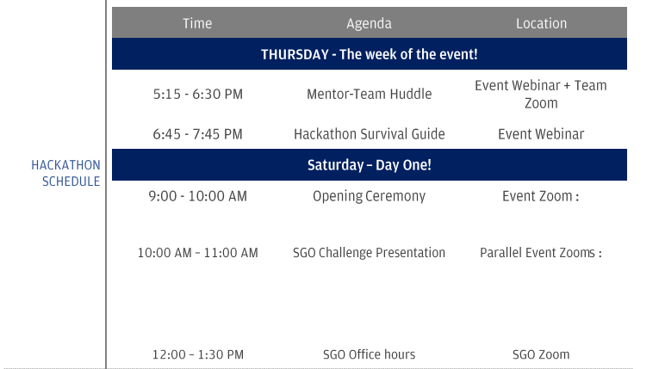
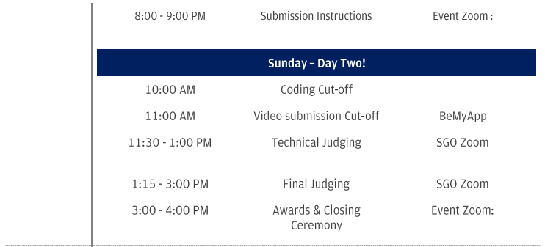
- SGO Assigned - Center for Gender and Politics
- Team No. 85
- Team Size - 8 (later reduced to 5, since people dropped out)
- No. of Mentors -2

- On 9th of june our team mates were released and immediately we found ourselves via linkedin and slack.we made our unofficial whatsapp group where there were no mentors present and then before mentor hurdle we connected on gmeet to get to know ourselves and with what technologies we are familiar with.we choose MERN Tech Stack and those who were not knowing these technology ,we gave them material to prepare before hackathon.

- During Hackathon 3 people were absent due to some reasons and out of present members also 2 were not familiar with Mern ,so we have to accept that fact and also work load was increased on remaining 3 members.

- During start because of this scenario i didn't felt that motivated because of lack of people and increase of whole load on 3 people but as we progressed we interacted with our mentors and they were really good who motivated us throughout the hackathon,He said “its okay we will still try and give our best”.

- I handled the whole frontend.It was tough but there was no option ,2 members did the backend and the remaining 2 helped in ppt and video making which was also important.

- Also don't start code early. Understand their requirements first and clear all doubts regarding statement then discuss with members on what unique thing you are providing which is not existing in current solution and then research on the unique feature which you are providing and then start to code.

- If you are stuck somewhere or facing errors and bugs don't waste time and immediately call SMEs and resolve errors.

- Learn a few popular tech stacks like MERN can come in handy since that’s what a lot of teams end up using. I’d recommend learning React, and Django and working with Databases like MySQL and MongoDB.Also keep authentication code template for login signup page ready before event only and don't waste time on these small things during crucial hours.You’ll also be provided with an EC2 instance that you can connect to, using their proprietary VPN, the credentials to which, will also be provided.

- Also Be comfortable with mentors. They are very frank with us and they really helped us a lot and maintained our spirits high during the whole hackathon.

- As this was a virtual event where we had to sit in one room for more than 30 hours, I felt exhausted because of a lot of load on me. I took a 20-25min break in between to relax my mind which is mandatory. There were 2 one to one mentor sessions in between. Those were like your Hr/Technical interview only.

- I didn't sleep the whole night and also to stay awake during the night i had maintained the stack of coffee,energy drinks.Mentors were not with us during night,only 2 members were there, i and one backend person was there and we did all connections during 4am ,rest of 3 members were off for bit and came back at 6am.

- At last I would say turn your obstacles into opportunities and find a way to overcome them.My overall Experience was very good because we faced almost everything from lack of people to not working connection between frontend and backend and many more,but in the end we did it,Unfortunately our team didn't win but we got placed due to our individual efforts.

Note: Winning or being a finalist is neither necessary nor a guarantee that you will be given an offer by JPMC. So, do not get disheartened, if you cannot get to the finals.Also
There is also a chance of you not getting an offer,so start preparing for the aptitude test of other companies.

Tips:
- Do not lose your calm if any teammate is not able to cope-up. Swap tasks and give him/her an easier task instead. This shows you can get the best out of everyone without losing cool.
- Keep your mentors updated with your status and everyone’s status and give them a holistic view of the progress. This shows that you can take responsibility of the entire team.
- Lastly, the product or the quality of the product you develop has very little to do with getting an offer. What matters is your individual performance and how you bring everything and everyone together.

All The Best :)

